

Student Project Management System

Common Project Documentation


Prepared By
Prof. Madhuresh Fichadiya
Computer Science and Engineering
Darshan University
A.Y. - 2026-27

Table of Contents
1. Project Goals & Objectives 3
Overview 3
Goals 3
Objectives 4
2. Scope of the Project 5
3. Project Timeline 6
4. Database Overview 7
5. Functional Requirements 9
6. Screen List 10 9
7. Screen Design Reference 11

Project Goals & Objectives

Overview
- The Student Project Management System is a role-based Web API application developed using ASP.NET Core technology. The system is designed to manage academic projects assigned to students under faculty supervision.
- The application provides separate access and permissions for Admin, Faculty, and Students. The system focuses on project allocation, task management, score tracking, progress monitoring, and secure role-based authorization.
- The system follows enterprise-level architecture practices while maintaining moderate project complexity suitable for academic implementation.

Goals
- Design a Normalized Database Structure:
▪ Create efficient and normalized tables to manage Users, Roles, Permissions, Projects, Project Allocations, and Tasks.
▪ Implement proper primary and foreign key relationships, including one-to-many and many-tomany associations wherever required to maintain data integrity and consistency.
- Implement CRUD & Authentication Functionality:
▪ Develop Create, Read, Update, and Delete operations for all major entities such as Students, Faculty Members, Projects, Tasks, and Role Management.
▪ Ensure secure user authentication and authorization using JWT tokens, along with smooth data management through role-based access control mechanisms.
- Ensure Data Integrity and Validation:
▪ Ensure that users can easily access project information, monitor progress, and perform their assigned responsibilities based on their roles.
- Develop an Intuitive User Interface:
▪ Provide a clean, user-friendly, and responsive frontend for efficient management of academic projects and related activities.
- Encourage Good Software Development Practices:
▪ Apply layered architecture principles, separation of concerns, and modular coding practices to improve maintainability and scalability.
▪ Utilize design patterns, DTOs, dependency injection, and proper exception handling to develop a robust and enterprise-ready application.
- Facilitate Effective Project Monitoring and Evaluation:
▪ Enable faculty members to assign tasks, track student performance, and provide remarks and evaluations throughout the project lifecycle.
▪ Automatically calculate project progress and score statistics to support informed academic decision-making.

Objectives
- Student Management:
▪ Enable administrators to create, view, update, and manage student profiles, including personal information, contact details, academic information, and project assignments.
▪ Allow students to update their own profile information and view project-related details assigned to them.
- Faculty Management:
▪ Provide functionality to create and maintain faculty profiles, including departmental information, contact details, and areas of expertise.
▪ Allow faculty members to supervise allocated projects and monitor the progress of assigned students.
- Role and Permission Management:
▪ Enable administrators to define and manage user roles such as Admin, Faculty, and Student.
▪ Implement role-based permissions to ensure that users can access only the functionalities relevant to their responsibilities.
- Project Management:
▪ Facilitate the creation, modification, viewing, and deletion of academic projects, including project titles, descriptions, timelines, and status information.
▪ Allow faculty members to initiate and manage projects under their supervision while maintaining project lifecycle records.
- Project Allocation Management:
▪ Enable administrators to allocate projects to students and assign faculty supervisors for effective project guidance.
▪ Maintain allocation records to ensure proper tracking of project ownership and faculty responsibilities.
- Task Management:
▪ Provide functionality to create, assign, update, and manage project tasks associated with individual projects.
▪ Allow faculty members to define task priorities, deadlines, and expected outcomes for students.
- Student Performance and Score Evaluation:
▪ Facilitate the assignment of scores and remarks by faculty members based on the completion and quality of assigned tasks.
▪ Maintain records of earned scores and evaluations to support academic assessment processes.
- Progress Monitoring and Tracking:
▪ Automatically calculate and display task-wise and project-wise progress based on predefined evaluation criteria.
▪ Provide students and faculty members with real-time insights into project completion status and pending activities.
- Dashboard and Reporting:
▪ Provide role-specific dashboards displaying key information such as project statistics, task completion summaries, student performance metrics, and faculty supervision details.
▪ Generate meaningful reports to assist administrators and faculty members in monitoring overall project activities.
- Data Integrity and Validation:
▪ Ensure accurate and consistent data entry through appropriate validations, relational constraints, and business rules.
▪ Prevent invalid project allocations, duplicate records, unauthorized modifications, and inconsistencies in task evaluation and progress calculations.
- Authentication and Secure Access:
▪ Implement secure user authentication using JWT-based authorization mechanisms.
▪ Restrict access to system functionalities based on user roles and permissions to maintain confidentiality and system security.

Scope of the Project
- Student and Faculty Management
▪ Ability for administrators to manage student and faculty records, including personal information, contact details, and role assignments.
▪ Create and maintain faculty profiles with departmental affiliations and areas of expertise.
▪ Allow students to manage their profiles and access project-related information assigned to them.
- Role and Permission Management
▪ Create, update, and manage various user roles such as Admin, Faculty, and Student.
▪ Define and assign permissions to control access to different modules and functionalities within the system.
▪ Ensure secure role-based access to maintain data confidentiality and system integrity.
- Project Creation and Management
▪ Enable faculty members and administrators to create, update, view, and manage academic projects.
▪ Maintain project details such as project title, description, objectives, timelines, and project status.
▪ Support project lifecycle management, including project initiation, execution, completion, and archival.
- Project Allocation and Supervision
▪ Assign students to projects under the guidance of designated faculty supervisors.
▪ Maintain allocation records to track project ownership, supervision responsibilities, and allocation history.
▪ Restrict faculty members to viewing and managing only the projects allocated to them.
- Task Assignment and Progress Tracking
▪ Allow faculty members to create, assign, and manage project-related tasks for individual students or project teams.
▪ Define task priorities, deadlines, descriptions, and completion criteria.
▪ Monitor task completion status and automatically update progress percentages based on predefined evaluation logic.
- Input Validation and Error Handling
▪ Ensure that all project-related inputs, including project details, task assignments, allocations, and evaluations, are validated for correctness and consistency.
▪ Prevent duplicate records, invalid allocations, unauthorized actions, and incorrect score calculations through business rule enforcement.
▪ Provide meaningful error messages, warnings, and user-friendly notifications to guide users during system interactions.
- Reporting and Analytics
▪ Generate reports related to project progress, task completion, student performance, and faculty supervision activities.
▪ Support data export functionalities to facilitate academic reviews and administrative reporting requirements.
▪ Enable stakeholders to analyze project trends and monitor the effectiveness of project execution processes.

Project Timeline
Week No. | Week Date | Task List
1 | 22/06/2026 To  27/06/2026 | Study and analysis of existing Student Project Management Systems for understanding project requirements.
2 | 29/06/2026 To  04/07/2026 | Preparation of Common Layout for consistent UI and  Different Project Screens
3 | 06/07/2026 To  11/07/2026 | Screen Designs for List Pages and Add/Edit Pages
4 | 13/07/2026 To  18/07/2026 | API Project creation with Model Classes and Database creation using Migrations
5 | 20/07/2026 To  25/07/2026 | API CRUD Endpoints for 2 Modules and Consume the endpoints
6 | 27/07/2026 To  01/08/2026 | API CRUD Endpoints for next 2 Modules and Consume the endpoints
7 | 03/08/2026 To  08/08/2026 | API CRUD Endpoints for remaining Modules and Consume the endpoints
8 | 10/08/2026 To  15/08/2026 | API CRUD Endpoints with Different functionalities like sorting, pagination and filtering and UI Modification as required.
9 | 17/08/2026 To  22/08/2026 | Dashboard API Designs and Common Response for all the API endpoints and Create Dynamic UI for Dashboard.
10 | 24/08/2026 To  29/08/2026 | Input Validations using Fluent Validations with appropriate DTOs.
11 | 31/08/2026 To  05/09/2026 | Authentication & Authorization and Role Base Access  Controls Implementation using Json Web Tokens in API Project
12 | 07/09/2026 To  12/09/2026 | Authentication & Authorization and Role Base Access  Controls Implementation using Json Web Tokens Frontend Project
13 | 14/09/2026 To  19/09/2026 | Repository Pattern Implementation and Service Layer  Implementation
14 | 21/09/2026 To  26/09/2026 | Final Evaluation

Database Overview
SPM_Role
ColumnName | DataType | Remarks
RoleId | int | Primary Key
RoleName | nvarchar(50) | Not Null
Description | nvarchar(250) | Allow Null

SPM_User
ColumnName | DataType | Remarks
UserId | int | Primary Key
FullName | nvarchar(150) | Not Null
Email | nvarchar(150) | Not Null , Unique
Password | nvarchar(max) | Not Null
MobileNumber | nvarchar(15) | Not Null
ProfilePicturePath | nvarchar(500) | Image path, Not Null
IsActive | bit | Not Null
IsDeleted | bit | Allow Null, Soft Delete

SPM_UserRole
ColumnName | DataType | Remarks
RolePermissionId | int | Primary Key
RoleId | int | Not Null, FK → Roles
UserId | Int | Not Null, FK → Users

SPM_Status
ColumnName | DataType | Remarks
StatusID | Int | Primary Key
StatusName | Nvarchar(20) | Not Null
StatusCssClass | Nvarchar(100) | Not Null

SPM_Priority
ColumnName | DataType
PriorityID | Int | Primary Key
PriorityName | Nvarchar(20) | Not Null
PriortyCssClass | Nvarchar(20) | Not Null

SPM_Project
ColumnName | DataType | Remarks
ProjectId | int | Primary Key
ProjectTitle | nvarchar(200) | Not Null
Description | nvarchar(max) | Allow Null
StudentId | int | Not Null, FK → Users
FacultyId | int | Not Null, FK → Users
AssignedDate | datetime | Not Null, Default GETDATE()
IsDeleted | bit | Allow Null, Soft Delete
ProjectStatus | Int | Not Null, FK → Status
StartDate | datetime | Not Null
EndDate | datetime | Not Null
TotalTasks | int | Not Null, Auto Updated
CompletedTasks | Int | Not Null, Auto Updated
ProgressPercentage | decimal(5,2) | Not Null, Auto Calculated

SPM_Task
ColumnName | DataType | Remarks
TaskId | int | Primary Key
AllocationID | int | Not Null, FK → Allocation
TaskTitle | nvarchar(200) | Not Null
TaskDescription | nvarchar(max) | Allow Null
TaskStatus | Int | Not Null, FK → Status
PriorityID | Int | Not Null, FK → Priority
AssignedScore | decimal(5,2) | Not Null, Faculty-defined score
EarnedScore | decimal(5,2) | Allow Null, Obtained score
ProgressPercentage | decimal(5,2) | Not Null, Auto Calculated
StartDate | datetime | Allow Null
DueDate | datetime | Allow Null
CompletedDate | datetime | Allow Null
FacultyRemarks | nvarchar(500) | Allow Null
StudentRemarks | nvarchar(500) | Allow Null
IsDeleted | bit | Allow Null, Soft Delete

Functional Requirements
- Role Management: Priority - 1
- Manage Roles
- Prevent duplicate Roles
- User Management: Priority - 1
- Manage (Create, View, Edit, Delete) Users.
- Prevent duplicate entries
- Maintain audit fields (Created, Modified) automatically
- User-Role Management: Priority - 2
- Manage User Roles.
- Prevent Duplicates and Assign Roles accordingly.
- Status and Priority Management: Priority - 2
- Manage Status and Priority.
- Prevent duplicate entries.
- Project Management: Priority - 3
- Manage Project with Proper Faculty and Student Assignment.
- Prevent Duplicates
- Task Management: Priority - 3
- Create, update, view, and delete project tasks.
- Assign tasks to students with priorities and deadlines.
- Update task status (Pending, In Progress, Completed, Rejected).
- Prevent duplicate task assignments within the same project.
- Automatically calculate task progress percentages.
- Automatically update project completion percentages based on task evaluations.
- Dashboard and Reporting: Priority - 4
- Design role-based dashboards for Admin, Faculty, and Students.
- Provide project statistics and task completion summaries based on roles.
- Generate reports related to student performance and project progress.
- Support export functionality for reports in various formats where applicable.
- Authentication and Authorization: Priority – 4
- Implement secure login functionality using JWT authentication.
- Support logout and token validation mechanisms.
- Restrict access to APIs based on assigned roles and permissions.
- Ensure unauthorized users cannot access protected resources.

Screen List
- Authentication & Dashboard
  - Login Page: Role-based authentication (Admin / Faculty / Student) using JWT-based authorization.
  - Dashboard: Displays an overview of active projects, completed projects, pending tasks, upcoming deadlines, and project statistics based on the logged-in user's role.
  - Profile: View and update personal information, contact details, and profile picture for the logged-in user.
- Master Configuration o Role Management (List Page and Add/Edit Screens) o User Management (List, Profile, and Add/Edit Screens) o Role-User Management (List Page and Add/Edit Screens)
- Project and Task Management o Project Management (List Page, Detailed View and Add/Edit Screens) o Task Management (List Page, Detailed View and Add/Edit Screens)
- Dashboards and Reports
o Role based Dashboards (Admin/Faculty/Student Dashboards) o Reports for Different statistics as required.

Screen Design Reference
Login Page
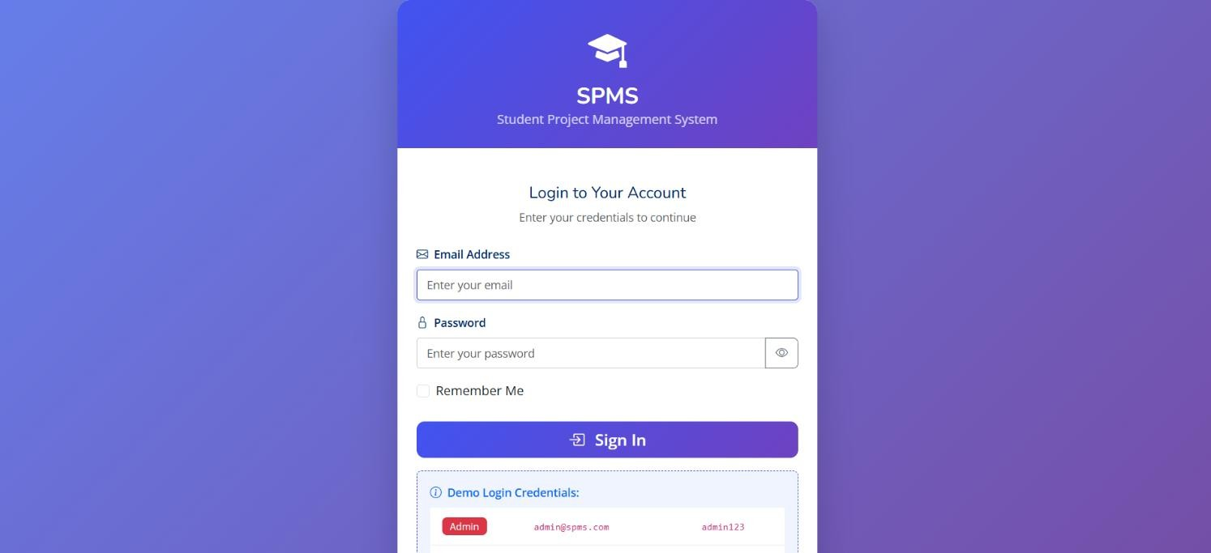
Dashboard
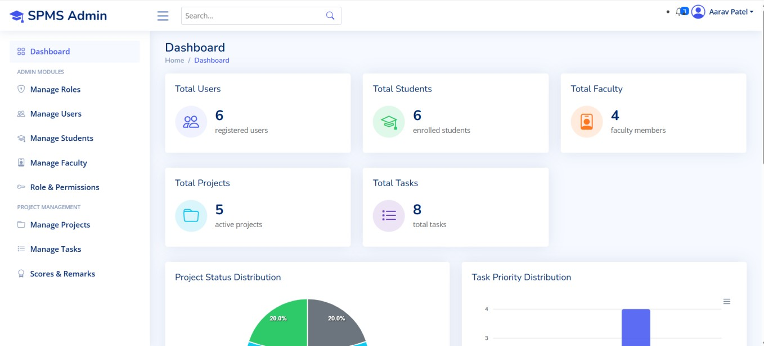

Manage Roles
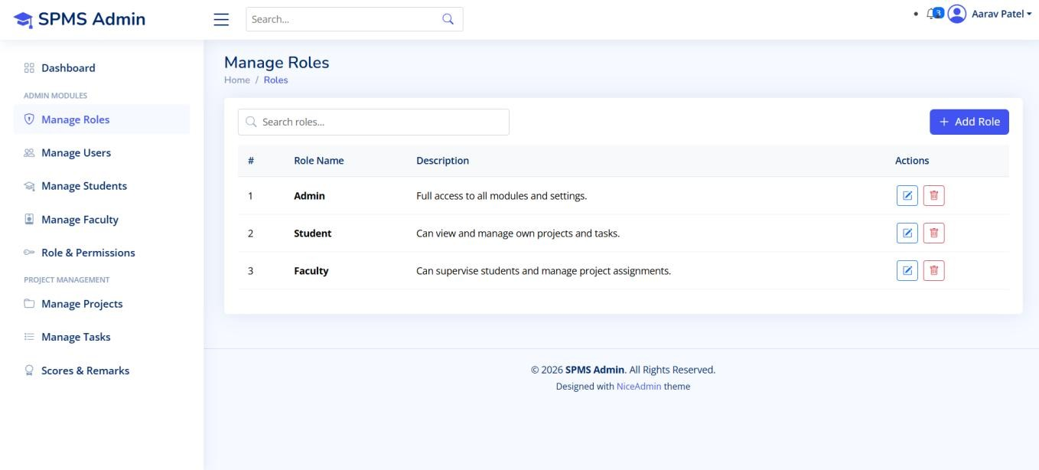
Roles Add/Edit Page
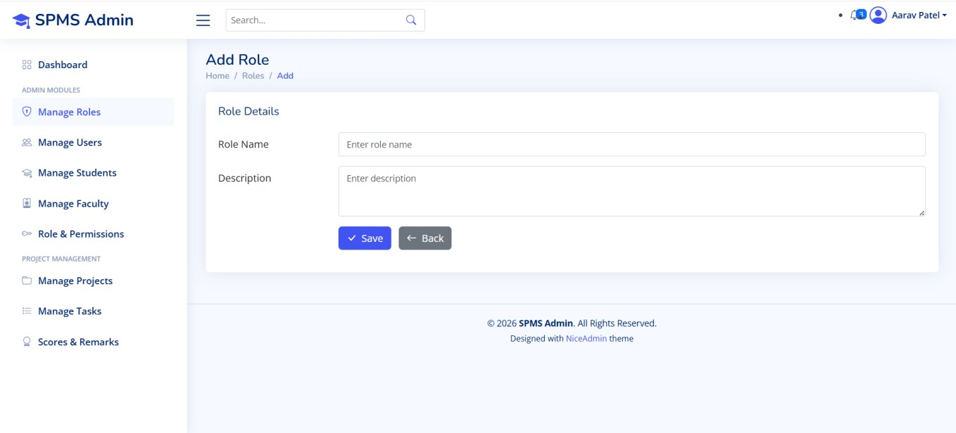

Manage Users
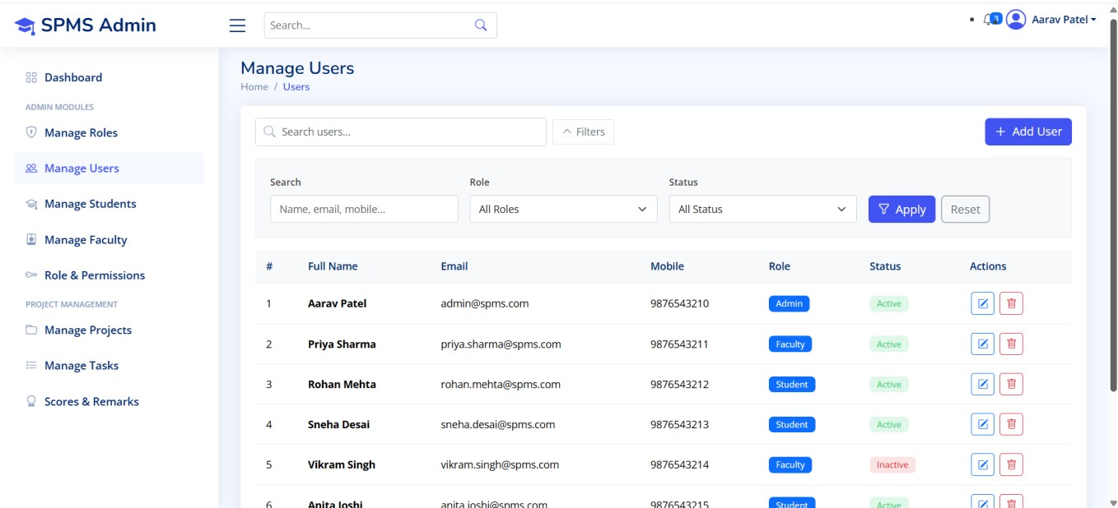
User Add/Edit Page
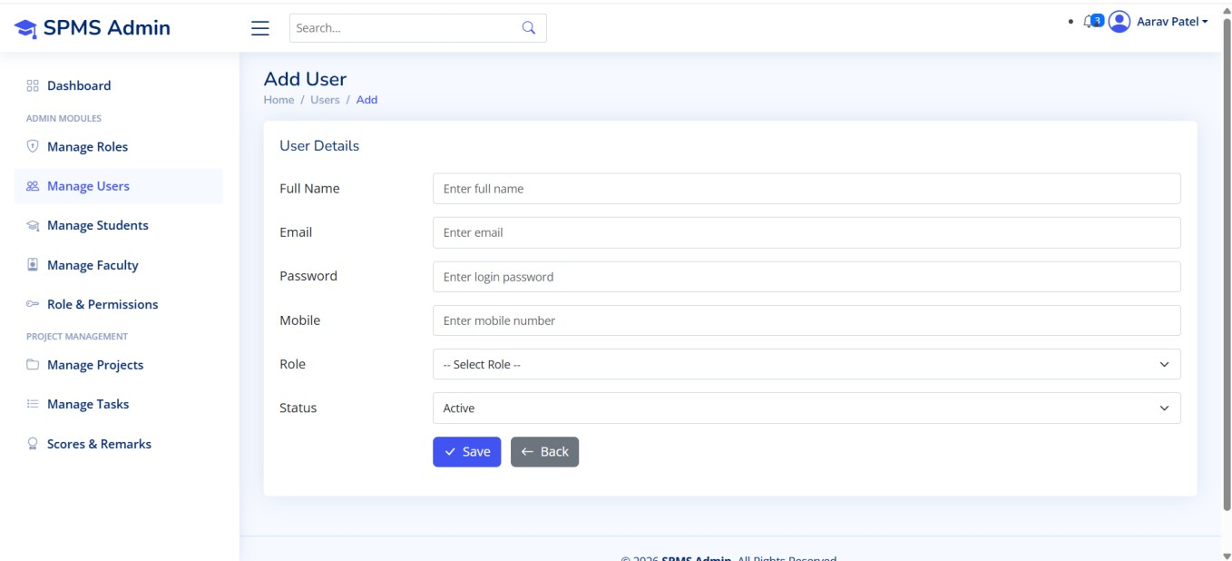

Manage Projects
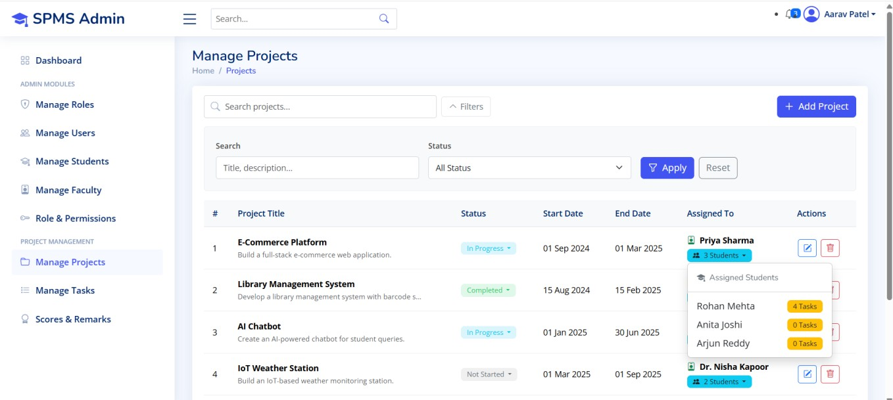
Project Add/Edit Page
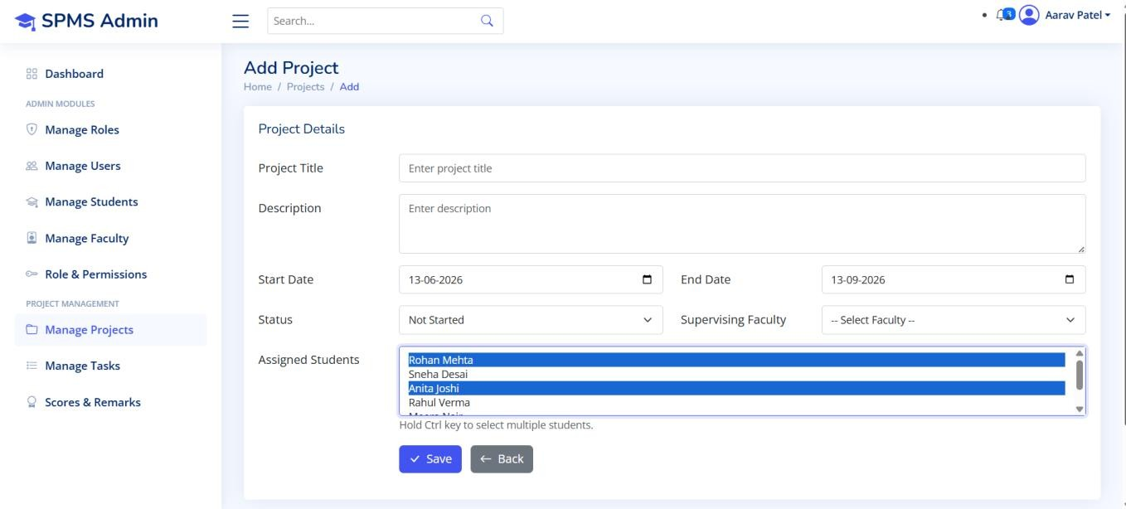
Manage Tasks
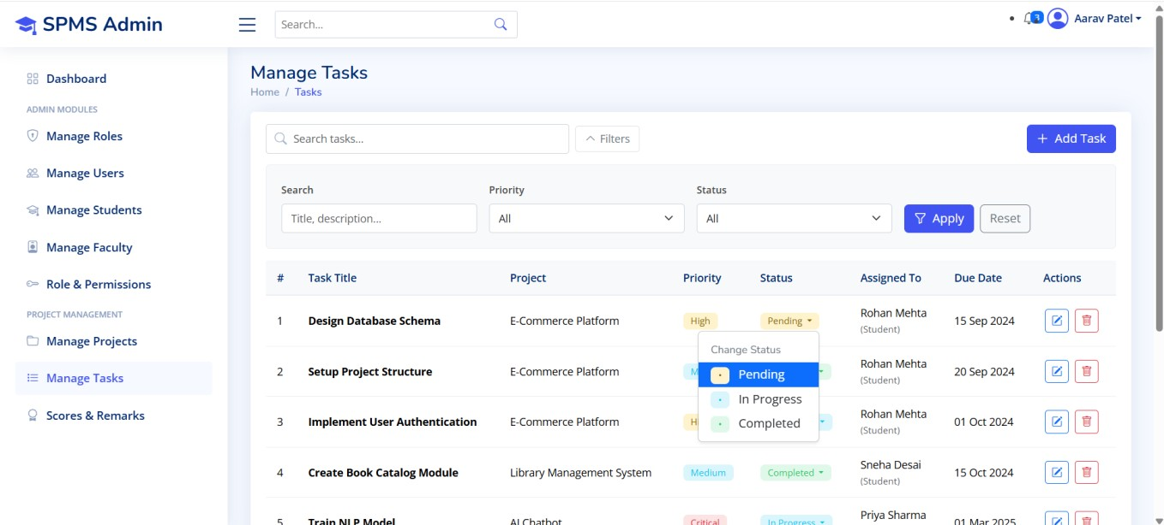
Task Add/Edit
